**CDACL - 006 - Market Analysis**



**Team ID:** PTID-CDA-DEC-24-283

**Project ID:** CDACL-006

**Project Name:** Market Analysis

**By**

***Team member 1: -***

**Name: Raasi P**

**Email:** [**rashireddy981212@gmail.com**](mailto:rashireddy981212@gmail.com)

***Team member 2: -***

**Name: Neetu Sharma**

**Email:** [**neets.2012@gmail.com**](mailto:neets.2012@gmail.com)

**Perform the Problem Queries:**

1. What are the top 10 aisles with the highest number of products?
2. How many unique departments are there in the dataset?
3. What is the distribution of products across departments?
4. What are the top 10 products with the highest reorder rates?
5. How many unique users have placed orders in the dataset?
6. What is the average number of days between orders for each user?
7. What are the peak hours of order placement during the day?
8. How does order volume vary by day of the week?
9. What are the top 10 most ordered products?
10. How many users have placed orders in each department?
11. What is the average number of products per order?
12. What are the most reordered products in each department?
13. How many products have been reordered more than once?
14. What is the average number of products added to the cart per order?
15. How does the number of orders vary by hour of the day?
16. What is the distribution of order sizes (number of products per order)?
17. What is the average reorder rate for products in each aisle?
18. How does the average order size vary by day of the week?
19. What are the top 10 users with the highest number of orders?
20. How many products belong to each aisle and department?

Also, analyse customer purchasing behaviour and product performance to optimize marketing strategies and improve customer satisfaction.

**Attributes information:**

1. **Aisles Dataset:**

* aisle_id: Unique identifier for the aisle. *(****Primary Keys****)*
* aisle: Name of the aisle.

1. **Departments Dataset:**

* department_id: Unique identifier for the department. *(****Primary Keys****)*
* department: Name of the department.

1. **Order Products Prior Dataset:**

* order_id: Unique identifier for the order. *(****Primary Keys****)*
* product_id: Unique identifier for the product.
* add_to_cart_order: Order in which the product was added to the cart.
* reordered: Indicates whether the product was reordered in this order (1 for reordered, 0 for not reordered).

1. **Orders Dataset:**

* order_id: Unique identifier for the order. *(****Primary Keys****)*
* user_id: Unique identifier for the user.
* eval_set: Evaluation set (prior, train, test).
* order_number: Order sequence number for the user.
* order_dow: Day of the week the order was placed.
* order_hour_of_day: Hour of the day the order was placed.
* days_since_prior_order: Number of days since the last order.

1. **Products Dataset:**

* product_id: Unique identifier for the product.
* product_name: Name of the product.
* aisle_id: Identifier for the aisle the product belongs to. *(****Primary Keys****)*
* department_id: Identifier for the department the product belongs to.

**QUERIES WITH ANSWERS**

**PERFORM THE PROBLEM QUERIES**

|  |
| --- |
| *1) What are the top 10 aisles with the highest number of products?*  SELECT count(*) AS Product_count, aisle_id  FROM products GROUP BY aisle_id  ORDER BY aisle_id DESC LIMIT 10; |
| *2) How many unique departments are there in the dataset?*  SELECT COUNT(DISTINCT department) AS Unique_departments  FROM departments; |
| *3) What is the distribution of products across departments?*  SELECT department_id, count(*) AS Product_count  FROM products GROUP BY department_id  ORDER BY department_id; |
| *4) What are the top 10 products with the highest reorder rates?*  SELECT reordered, product_id  FROM order_products_train  ORDER BY reordered  DESC LIMIT 10; |
| *5) How many unique users have placed orders in the dataset?*  SELECT COUNT(DISTINCT user_id) AS Unique_users  FROM orders; |
| *6) What is the average number of days between orders for each user?*  SELECT user_id, AVG(days_since_prior_order)  AS Avg_days_between_orders  FROM orders GROUP BY user_id; |
| *7) What are the peak hours of order placement during the day?*  SELECT order_hour_of_day, count(*) as order_count  FROM orders  GROUP BY order_hour_of_day  ORDER BY order_count DESC; |
| *8) How does order volume vary by day of the week?*  SELECT order_dow, count(*) AS order_count  FROM orders  GROUP BY order_dow  ORDER BY order_count DESC; |
| *9) What are the top 10 most ordered products?*  SELECT product_id, COUNT(*) AS product_count  FROM order_products_train  GROUP BY product_id  ORDER BY product_count DESC LIMIT 10; |
| *10) How many users have placed orders in each department?*  SELECT p.department_id, count(DISTINCT o.user_id) AS user_count  FROM products p JOIN order_products_train opt  ON p.product_id = opt.product_id  JOIN orders o ON opt.order_id = o.order_id  GROUP BY p.department_id; |
| *11) What is the average number of products per order?*  SELECT order_id, AVG(product_id) AS avg_products_per_order  FROM order_products_train  GROUP BY order_id; |
| *12) What are the most reordered products in each department?*  SELECT p.department_id, opt.product_id,  SUM(opt.reordered) AS reordered_products  FROM products p JOIN order_products_train opt  ON p.product_id = opt.product_id  GROUP BY opt.product_id  ORDER BY reordered_products DESC; |
| *13) How many products have been reordered more than once?*  SELECT COUNT(*) AS products_reordered_more_than_once  FROM  (SELECT product_id, SUM(reordered) AS reorder_count  FROM order_products_train  GROUP BY product_id HAVING reorder_count > 1)  AS subquery; |
| *14) What is the average number of products added to the cart per order?*  SELECT order_id, AVG(product_id) AS avg_product_count  FROM order_products_train  GROUP BY order_id; |
| *15) What is the average number of products added to the cart per order?*  SELECT order_hour_of_day, COUNT(*) AS order_number_count  FROM orders  GROUP BY order_hour_of_day  ORDER BY order_number_count DESC; |
| *16) What is the distribution of order sizes (number of products per order)?*  SELECT order_id, COUNT(*) AS no_of_products_per_order  FROM order_products_train  GROUP BY order_id; |
| *17) What is the average reorder rate for products in each aisle?*  SELECT p.aisle_id, AVG(opt.reordered) AS avg_reorder_rate  FROM order_products_train opt  JOIN products p ON opt.product_id = p.product_id  GROUP BY p.aisle_id; |
| *18) How does the average order size vary by day of the week?*  SELECT o.order_dow AS order_day, AVG(order_number) AS avg_order_size  FROM order_products_train opt  JOIN orders o ON opt.order_id = o.order_id  GROUP BY o.order_dow; |
| *19) What are the top 10 users with the highest number of orders?*  SELECT user_id, COUNT(order_id) AS order_count  FROM orders  GROUP BY user_id  ORDER BY order_count DESC  LIMIT 10; |
| *20) How many products belong to each aisle and department?*  SELECT aisle_id, department_id, COUNT(*) AS product_count  FROM products  GROUP BY aisle_id, department_id; |

**MySQL Execution with Explanation:**

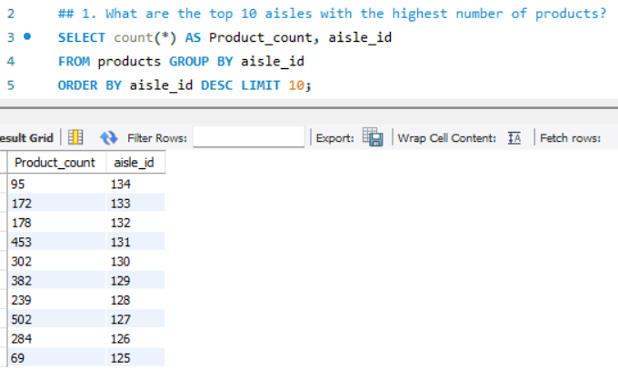

**Statement Explanation:** The above SELECT Statement retrieves count products (COUNT(*)) grouped by aisle_id. Sort by product count (ORDER BY Product_count DESC) and limit to the top 10 aisles (LIMIT 10) as shown in the result.

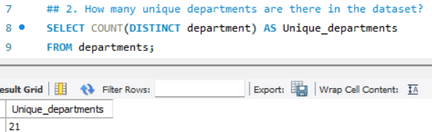

**Statement Explanation:** The above SELECT Statement retrieves COUNT(DISTINCT department_id) to count unique department IDs in the departments table as shown in the result.

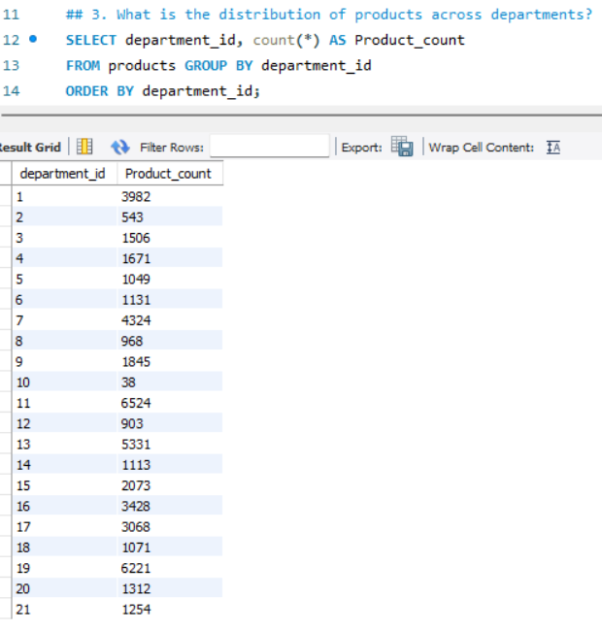

**Statement Explanation:** The above SELECT Statement retrieves count products grouped by department_id. Sort by department_id as shown in the result.

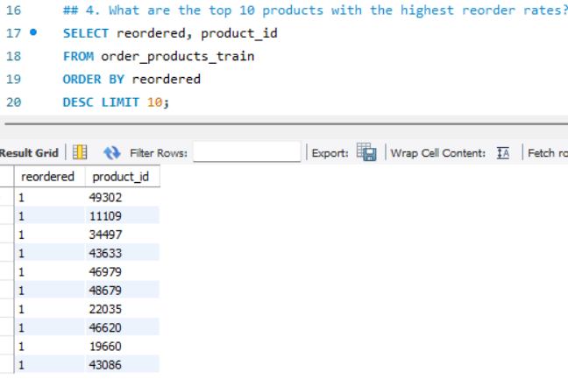

**Statement Explanation:** The above SELECT Statement retrieves calculated average reorder rate (AVG(reordered)) for each product_id. Sort by reorder rate and take the top 10 as shown in the result.

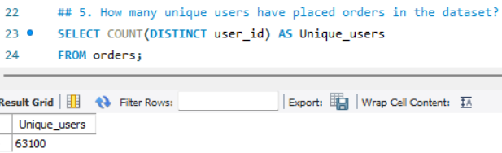

**Statement Explanation:** The above SELECT Statement retrieves COUNT(DISTINCT user_id) to count unique users in the orders table as shown in the result.

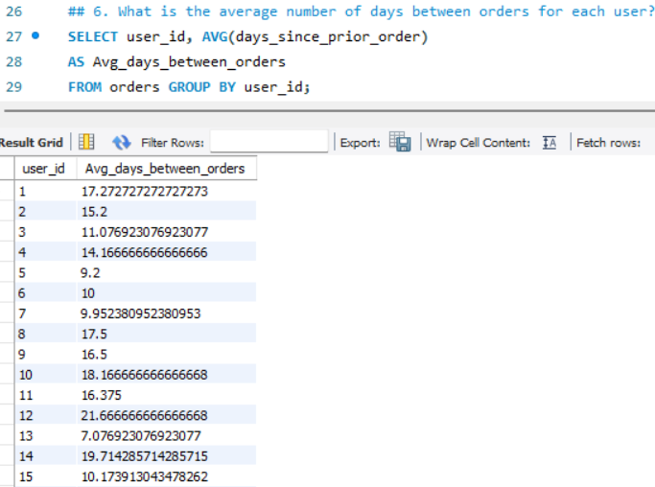

**Statement Explanation:** The above SELECT Statement retrieves group by user_id and compute the average (AVG(days_since_prior_order)) as shown in the result.

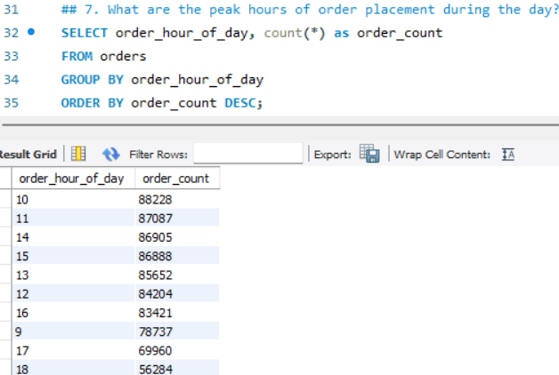

**Statement Explanation:** The above SELECT Statement retrieves count orders for each hour (order_hour_of_day). Sort by order count in descending order as shown in the result.

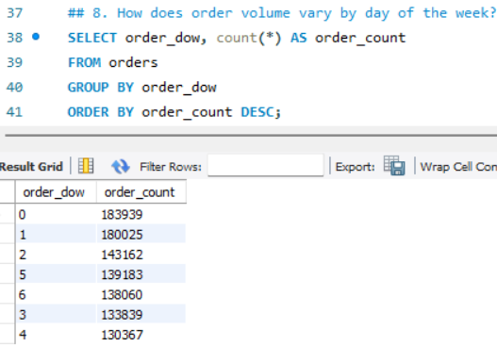

**Statement Explanation:** The above SELECT Statement retrieves count orders for each order_dow. Sort by order count in descending order as shown in the result.

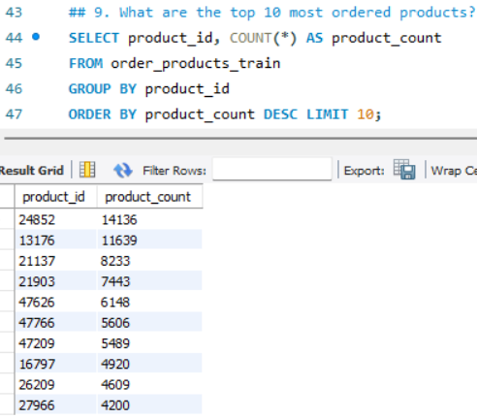

**Statement Explanation:** The above SELECT Statement retrieves count orders for each product_id. Sort by order count and take the top 10 as shown in the result.

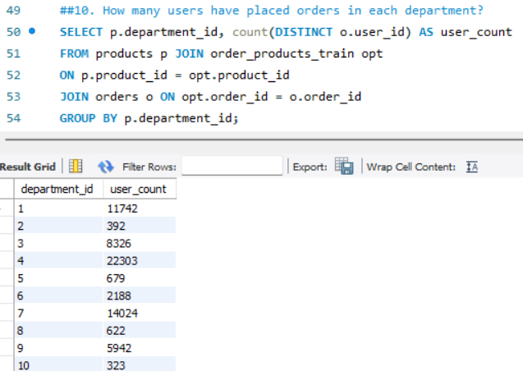

**Statement Explanation:** The above SELECT Statement retrieves join of products from order_products_train, and orders tables. Group by department_id and count unique user_id as shown in the result.

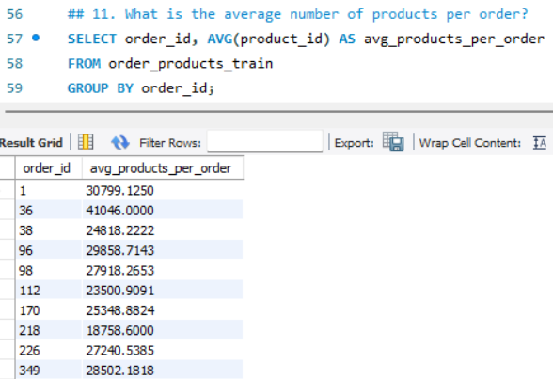

**Statement Explanation:** The above SELECT Statement retrieves group by order_id and compute the average number of products as shown in the result.

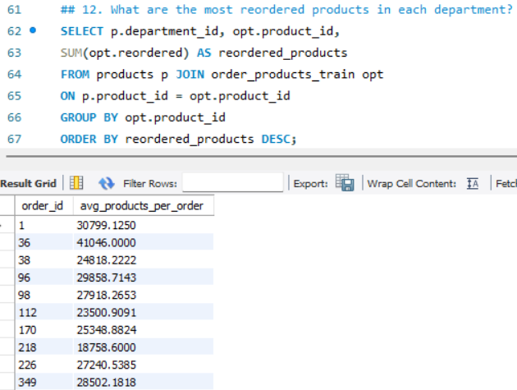

**Statement Explanation:** The above SELECT Statement retrieves join of products and order_products_train, group by department_id and product_id, and sum reorders (SUM(opt.reordered)) as shown in the result.

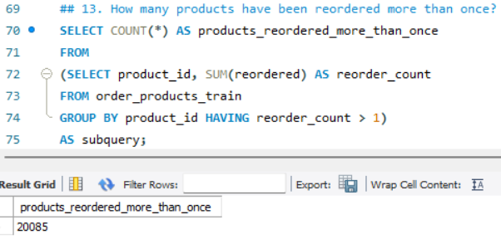

**Statement Explanation:** The above SELECT Statement retrieves filtered products with SUM(reordered) > 1 and count them as shown in the result.

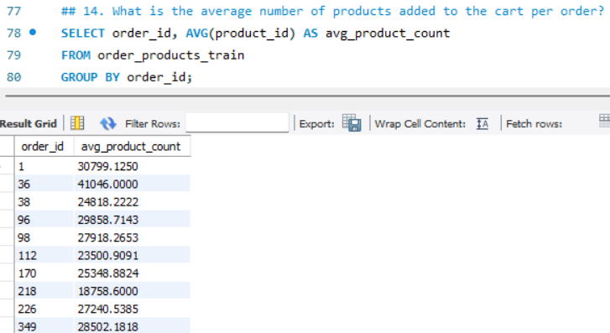

**Statement Explanation:** The above SELECT Statement retrieves group by order_id and compute the average number of products as shown in the result.

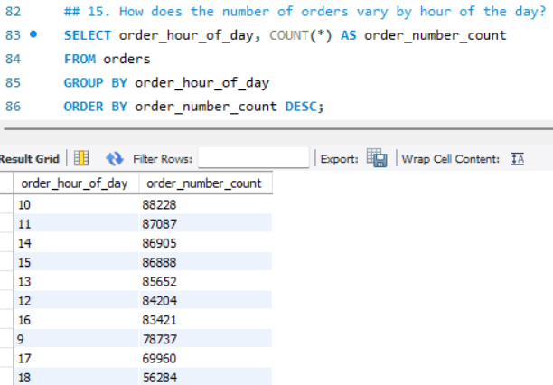

**Statement Explanation:** The above SELECT Statement retrieves count orders grouped by order_hour_of_day as shown in the result.

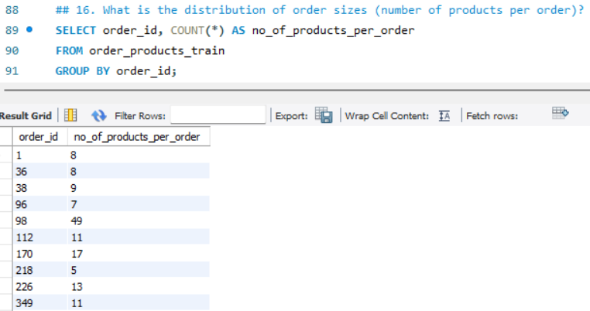

**Statement Explanation:** The above SELECT Statement retrieves count products grouped by order_id as shown in the result.

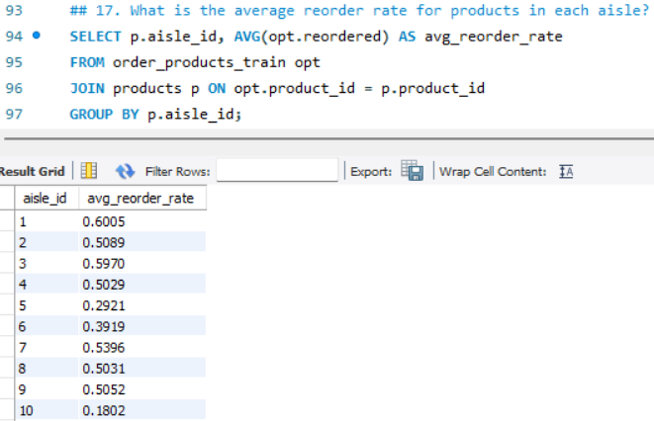

**Statement Explanation:** The above SELECT Statement retrieves join of products and order_products_train. Group by aisle_id and compute AVG(reordered) as shown in the result.

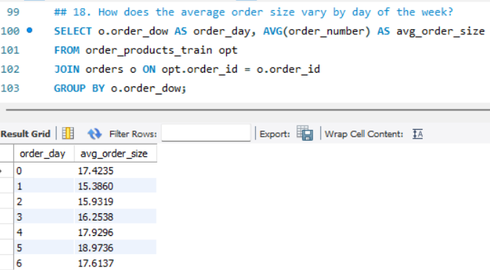

**Statement Explanation:** The above SELECT Statement retrieves join of orders and order_products_train, group by order_dow, and compute the average order size as shown in the result.

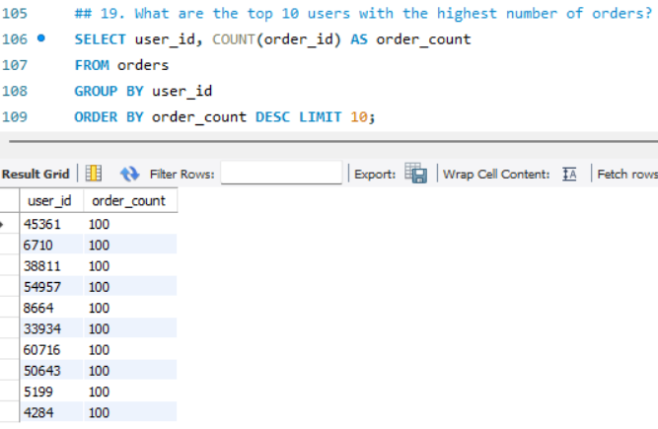

**Statement Explanation:** The above SELECT Statement retrieves group by user_id and count orders. Sort and take the top 10 as shown in the result.

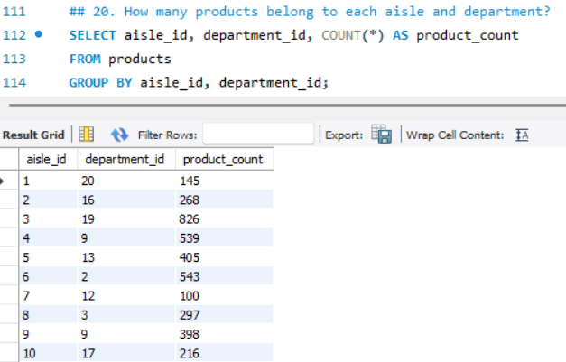

**Statement Explanation:** The above SELECT Statement retrieves group by aisle_id and department_id and count products as shown in the result.